Investigating the Dynamics of Trust Surrounding Marine Resource Management in Maunalua Bay, Oʻahu
Prepared For: Mālama Maunalua
Prepared By: Philip Kitamura, Cole Hendrickson & Angelica Melone
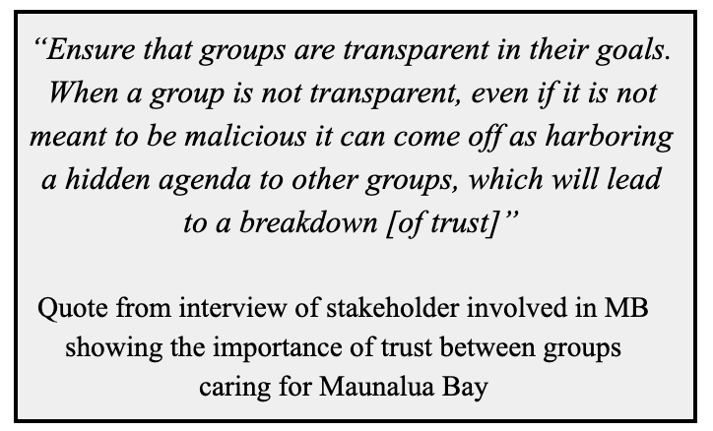
Defining Trust in Maunalua Bay:
Trust is critical when managing natural resources, initiating stakeholder relationships, collaboration, and motivation for co-management (Stern and Coleman 2014, Ostrom 1990). Investigating the dimensions of trust currently between stakeholders within Maunalua Bay (MB) provides the opportunity to better understand where critical trust, and gaps in trust, exist. Identification of these are relevant to Mālama Maunalua, NGOs, and others in the area when thinking about building, improving, and sustaining relationships through trust.
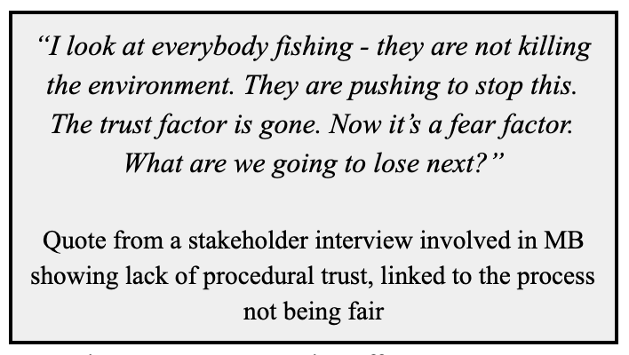
Methods: Six interviews of individuals representing different stakeholder user groups of the bay guided our discourse analysis. After conducting interviews and coding for trust, we found that the proposed NOAA whale sanctuary in MB (2015) was a recurring event that produced distrust among user groups of the bay. Using the framework from Stern and Coleman (2014), we were able to categorize types of trust to determine specific opportunities for reconstructing trust in the bay (see full report). This was used to inform a discourse analysis of 31 public comments on the proposed sanctuary.

Results: Our analysis of interviews showed an overall trend of distrust among the landscape of MB stakeholders. In total, 150 cases of distrust (86%) were conveyed, and just 25 cases of trust (14%) were found. MB is characterized by low levels of trust between, and among, various entities and stakeholder groups. Lack of trust potentially serves as a barrier for successful conservation efforts in the bay. The most common forms of distrust were procedural and rational. Procedural pertains to distrust in the way that decision-making processes surrounding natural resources are designed. Rational trust is linked to negative interactions with specific entities or individuals in the past. Results from our discourse analysis revealed the majority of the distrust stems from a lack of procedural trust.
Conclusions:
As trust emerged as a key concern within MB, efforts to improve trust could be taken through developing marine resource management processes that are consistently transparent and inclusive, where scientists, managers, and NGOs commit to long-term trust building through developing a positive set of interactions with other stakeholder groups. By looking to the past, we found that lessons can be learned, and opportunities illuminated for organic ways for stakeholders to incorporate improved trust within current and future processes involving MB.

