**Table 1**

*Correlations with Aggressive Humor*

|  | **Population** | |  | **Correlations with Aggressive Humor** |
| --- | --- | --- | --- | --- |
|  | ***N*** | **Sample** | | **(+ = positive correlation; - = negative correlation)** |
| (Bippus et al., 2012) | 442 | U.S. West Coast University  U.S. South-Central University | | (+) funniness, likability, counterarguing, credibility |
| (Cann & Matson, 2014) | 353 | North Carolina, United States | | (+) maladaptive humor = socially undesirable |
| (DiDonato & Jakubiak, 2016) | 224 | Mid-Atlantic Jesuit University/ workers on MTurk | | (-) humor production, short-term relationships |
| (Dozois et al., 2013) | 208 | Psych students  University of Western Ontario | | (+) anger, hostility, physical and verbal aggression |
| (Greengross & Miller, 2011) | 96 | Intro – Psych students  University of New Mexico | | (-) agreeableness, neuroticism |
| (Hampes, 2016) | 112 | Midwest community  college students | | (-) forgiveness likelihood, presences of positive |
| (Hugelshofer et al., 2006) | 418 | Intro-Psych students  Pacific Northwest | | (+) depressive symptoms among women |
| (Kazarian & Martin, 2006) | 278 | Lebanese Residents | | (+) horizontal individualism  (-) horizontal collectivism, vertical collectivism, vertical individualism, family adjustment |
| (Kuiper & Harris, 2009) | 105 | Undergrad Psych students | | (+) dysfunctional coping patterns, greater denial, reduction in the ability to change perspective |
| (Martin et al., 2003) | 1195 | Intro – Psych students  University of Western Ontario | | (+) neuroticism, unmitigated masculinity  (-) agreeableness, conscientiousness, femininity |
| (Martin et al., 2012) | 200 | Psych students | | (+) Machiavellianism, psychopathy |
|  | **Population** | |  | **Correlations with Aggressive Humor** |
|  | ***N*** | **Sample** | | **(+ = positive correlation; - = negative correlation)** |
| (Masui et al., 2013) | 139 | Undergraduate students, Japan | | (+) psychopathy, social exclusion |
| (Mauriello & McConatha, 2007) | 182 | Psych students  The University of Pennsylvania,  community adults | | (+) coping humor scale |
| (Ozyesil, 2012) | 440 | Turkey | | (-) self-esteem |
| (Ruch & Heintz, 2019) | 570 | Swiss (70.7%)  German (20.9%) | | (+) sarcasm, fun, irony |
| (Sari, 2016) | 489 | High School students  Turkey | | (+) cyberbullying |
| (Taher et al., 2008) | 435 | Lebanon | | (+) depressive symptoms, social anxiety, social avoidance |
| (Tucker et al., 2013) | 306 | Psych students | | (+) symptoms of depression |
| (Veselka et al., 2010b) | 114 | Twins from Canada and the United States | | (+) psychopathy, Machiavellianism |
| (Veselka et al., 2010a) | 1186 | Twins from King's College London, England | | (-) honesty-humility, emotionality, agreeableness, conscientiousness |
| (Winterheld et al., 2013) | 96 | Intro psychology students who were in a relationship | | (+) avoidant attachment (-) partner satisfaction with conflict resolution |
| (Wu et al., 2016) | 431 | Taiwan adolescents | | (-) empathy, perspective-taking |
| (Yip & Martin, 2006) | 111 | Undergrad students  University of Western Ontario | | (-) emotional perception, provide emotional support to others, ability to manage conflicts in relationships |
| (Yue et al., 2014) | 337 | City University of Hong Kong (159)  Hangzhou Normal University (178) | | (+) Hong Kong (-) Hangzhou  (ns) emotional loneliness and social loneliness |

**Table 2**

Descriptive Statistics and Intercorrelations

|  |  |  |  |  |  |  |  |  |  |  |  |  |  |
| --- | --- | --- | --- | --- | --- | --- | --- | --- | --- | --- | --- | --- | --- |
|  | *M* | *SD* | 1 | 2 | 3 | 4 | 5 | 6 | 7 | 8 | 9 | 10 | 11 |
| 1. Affiliative Humor | 5.10 | 1.19 | - |  |  |  |  |  |  |  |  |  |  |
| 2. Self-enhancing Humor | 4.78 | 1.09 | 0.49** | - |  |  |  |  |  |  |  |  |  |
| 3. Aggressive Humor | 3.45 | 1.05 | 0.06 | 0.14** | - |  |  |  |  |  |  |  |  |
| 4. Self-defeating Humor | 3.69 | 1.23 | -0.04 | 0.15** | 0.42** | - |  |  |  |  |  |  |  |
| 5. Intrasexual Competition | 2.98 | 1.48 | -0.30** | 0.07 | 0.36** | 0.46** | - |  |  |  |  |  |  |
| 6. Courtship | 4.81 | 1.14 | 0.01 | 0.20** | 0.16** | 0.37** | 0.55** | - |  |  |  |  |  |
| 7. SOI-R | 4.14 | 1.77 | -0.07 | 0.15** | 0.42** | 0.27** | 0.33** | 0.18** | - |  |  |  |  |
| 8. Machiavellianism | 3.10 | 0.86 | -0.17** | 0.02 | 0.49** | 0.32** | 0.61** | 0.42** | 0.41** | - |  |  |  |
| 9. Narcissism | 2.98 | 1.26 | -0.09 | 0.20** | 0.31** | 0.30** | 0.66** | 0.47** | 0.34** | 0.58** | - |  |  |
| 10. Psychopathy | 2.11 | 1.47 | -0.29** | 0.07 | 0.50** | 0.46** | 0.70** | 0.36** | 0.57** | 0.62** | 0.64** | - |  |
| 11. Physical Strength | 50.70 | 24.22 | -.012* | 0.11* | 0.16** | 0.14** | 0.37** | 0.21** | 0.26** | 0.45** | 0.33** | 0.40** | - |
| 12. Attractiveness | 52.80 | 23.68 | -0.11* | 0.09 | 0.14** | 0.09 | 0.40** | 0.26** | 0.23** | 0.54** | 0.36** | 0.37** | 0.68** |
| **. Correlation is significant at the 0.01 level (2-tailed). | | | | | | | | | | | | | |
| *. Correlation is significant at the 0.05 level (2-tailed). | | | | | | | | | | | | | |

**Table 3**

Regression Analysis on Use of Aggressive Humor

|  |  |  |  |  |  |  |
| --- | --- | --- | --- | --- | --- | --- |
|  | Model 1 | Model 2 | Model 3 | Model 4 | Model 5 | Model 6 |
| Intercept | 2.67 *** (0.11) | 2.85 *** (0.22) | 2.09 *** (0.14) | 2.66 *** (0.14) | 2.00 *** (0.18) | 2.03 ***  (0.25) |
| Intrasexual Competition | 0.26 *** (0.34) | 0.29 *** (0.04) | 0.18 *** (0.03) | 0.26 *** (0.03) | -0.02  (0.5) | 0.29  (0.50) |
| Courtship |  | -0.50  (0.05) |  |  |  | -0.06  (0.5) |
| SOI-R |  |  | 0.20 *** (0.03) |  |  | 0.10 ** (0.03) |
| Physical Strength |  |  |  | -0.00  (0.00) |  | -0.00  (0.00) |
| Attractiveness |  |  |  | -0.00  (0.00) |  | -0.00  (0.00) |
| Machiavellianism |  |  |  |  | 0.39 *** (0.07) | 0.38 *** (0.07) |
| Narcissism |  |  |  |  | -0.10  (0.05) | -0.05  (0.06) |
| Psychopathy |  |  |  |  | 0.28 *** (0.05) | 0.20 *** (0.05) |
| *R2* | 0.13 | 0.13 | 0.23 | 0.13 | 0.30 | 0.33 |
| Degrees of Freedom | 378 | 378 | 378 | 378 | 377 | 378 |
| *Notes.* The first line is unstandardized regression coefficients, followed by standard error in parentheses. | | | | | | |
| ***. Correlation is significant at *p* < 0.001 level (2-tailed). | | | | | | |
| **. Correlation is significant at *p* = 0.01 level (2-tailed). | | | | | | |

**Figure 1**

The Procedure of Methods



**Figure 2**

*Relationship Correlations with the Motive to Intrasexually Compete and the Use of Aggressive Humor*

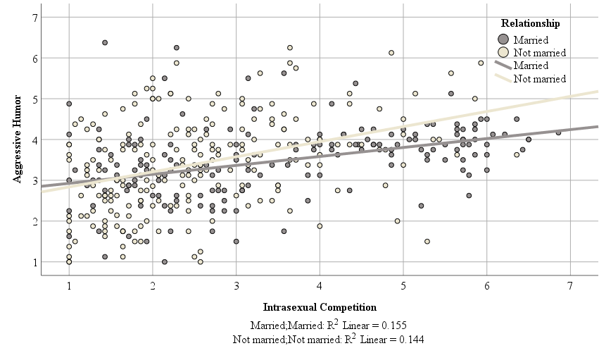

**Figure 3**

*The Sex Differences in the Use of Different Types of Humor*

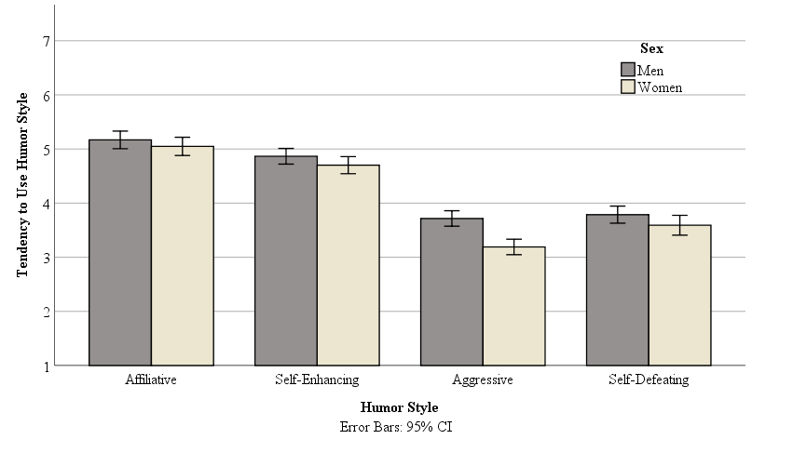

**Figure 4**

Sex Correlations with the Motive to Intrasexually Compete and Tendency to Use Aggressive Humor

