Jesse Joseph
University of Hawaii - LTEC
Jjoseph4@hawaii.edu

Abstract: Low-income and first-generation students entering college often do not have the same context for understanding financial literacy as students who come from more economically stable backgrounds. Without adequate support or equal access to content, these students often enter college with less financial aid than they could have qualified for. It is important for these students to have the tools needed to understand this information as it directly impacts lives. To address this problem, this project designed and evaluated a financial literacy toolkit. The evaluation examined the toolkit’s impact on participants’ (n = 15) satisfaction, perceived value, and ease of use. The results suggest the resource may assist students in understanding and completing financial aid steps throughout their academic journey.

Introduction

As students begin or continue their post-secondary education, most of them seek out information about financial aid. While this information can be obtained from counselors, advisors, friends, and parents, it always begins and ends with the student’s ability to navigate this complex process on their own. Furthermore, financial aid is not something that can simply be completed once. Instead, it is an evolving process that must be readdressed each year a student is in college.

As the cost of college attendance rises, universities strive hard to make sure students have access to financial literacy education. Financial literacy is defined by the US Treasury department as the skills, knowledge, and tools that equip people to make individual decisions to attain their goals. The learned skill set of financial literacy assists students in making informed decisions regarding their finances. While some universities have been successful in providing their own information through on-campus resources, this information tends to reach only a limited community of students who are actively seeking information. Unfortunately, first-generation, low-income students, who are less likely to have contact with financial aid experts, are most at risk in terms of their persistence being affected by a lack of funding for college (Alon, 2011). The uncertainty tied to the processes, and the lack of reliable financial aid to help them afford a college education, presents a significant barrier to student success. To eliminate this barrier, students must be supplied with a direct resource that explains the financial fundamentals they need to know and do, each year they will be attending university. Specifically, students must be supplied direct instruction on the three principles of financial literacy: the Free Application for Federal Student Aid (FAFSA), scholarships, and loans.

Financial literacy education is imperative to college students because it is one of the main reasons students reach their educational goals. Data taken from the National Survey of Educational Statistics measuring students’ financial aid and socioeconomic status shows a correlation between students from low-income houses and higher dropout rates compared to students from wealthier families (Chen & DesJardins, 2008). According to Alon (2011), receiving financial aid also increases graduation rates, especially for students from low-income families. Furthermore, the National Postsecondary Student Aid Study (2020) reported that two-thirds of students who did not apply for financial aid actually could have qualified for some level of assistance (Hodara, n.d.). This suggests that even with the existing amount of access students have to financial aid assistance, more work needs to be done to increase the accessibility of financial aid resources.

The purpose of this project was to create a financial literacy toolkit for students attending the University of Hawaii Maui College. Additionally, the project aimed to evaluate the toolkit for user satisfaction, perceived value, and ease of use. This toolkit will serve as a reference point not just for new students but for students who are expected to fulfill financial aid applications in subsequent years during their study. In addition, this toolkit contains information and instruction on the FAFSA, primary scholarships related to the institution, and both unsubsidized and subsidized loans. This toolkit aims to provide clear and comprehensive instruction on financial literacy basics that can be readily shared between households. Due to the high number of first-generation households in Maui County, it was important to design a resource that will serve this community. The purpose of this online toolkit is to reduce common barriers such as difficulty accessing the material, lack of context, and discouragement.

Literature Review

Financial Literacy

Financial aid and understanding the process of applying for it can be the deciding factor in a student’s ability to attend higher education. While much work has been done in the field of financial aid, it is still not reaching the majority of students who are looking to attend university. A recent survey of over 100,000 incoming college students from across the United States, found that a majority of students failed to answer basic questions about financial literacy pertaining to borrowing, saving, and applying for financial aid (National Association of Student Financial Aid Admissions, 2018). This lack of understanding can be attributed to multiple factors. The same study showed only 40% of students participated in a financial literacy course while attending high school or otherwise. These statistics are important because students who lack basic knowledge regarding financial literacy often find themselves taking out loans and getting into debt. These poor choices result in students feeling high levels of financial anxiety, which can lead to high levels of stress and potentially affect decision-making (Archuleta et al., 2013). A 2013 study showed that any amount of debt can cause equal levels of anxiety in the borrower, especially when the debt has to do with student loans (Archuleta et al., 2013). Financial stress is proven to have negative effects on overall college retention and graduation rates (Heckman et al., 2014), as well as long-lasting effects on short-term and long-term goals (Fosnacht, Calderone 2017). Any project about financial literacy should address these concerns by educating students on basic concepts as well as recurring themes for prolonged financial well-being.

Low-income and First-Generation Students. Addressing the cost of attendance and navigating the applications for financial aid can be a strain on any student, though some may find it more difficult than others. Low-income or first-generation students may have an increased risk of being affected by the cost of college and the availability of financial aid. Research has highlighted the fact that there is a difference in the dropout rates of low-income students and their upper-income peers. For example, a study conducted by Chen and DesJardins (2008), found that when measuring students based on parental income, students from low-income backgrounds dropped out before their second semester at a 33% average, while students from higher-income demographics were down to 22%. The study additionally found a positive correlation between students whose parents had not graduated from higher education and a higher risk of premature postsecondary departure. Work done to expand access to these materials may combat these challenges to some degree, by offering additional opportunities for students to learn about financial aid and financial literacy.

The FAFSA. Financial literacy is a broad concept that includes the ability to utilize and understand various financial skills such as budgeting, financial management, and money borrowing. With the cost of attendance for public and private universities rising 50-60% in the last 10 years (USAFacts, n.d.) and with the average debt of students exiting colleges nearing 30,000 dollars in 2019 (College Board, 2019), the importance of understanding these concepts has never been more dire. The Free Application for Federal Aid (FAFSA) is a student's first step to getting access to funds that can offset the price of school. Through the FAFSA, students may be eligible to receive the Pell Grant, an educational grant given to students from low-income households. The FAFSA is also an easy way for students to apply for student loans. Students are shown to be statistically more likely to receive more money overall if they file the FAFSA and file it on time (McKinney & Novak, 2015). Furthermore, need-based financial aid such as the Pell Grant is an effective way of bridging the college persistence gap between low-income students and their affluent peers (Alon, 2011). This makes the FAFSA one of the easiest methods for low-income students to start their college planning. This important information about the FAFSA, as well as a curated selection of other financial aid opportunities, creates the backbone of information for any financial literacy website.

Understanding one concept of the financial aid process is not sufficient for students' financial education. Even though the FAFSA is considered one of the most useful tools for obtaining aid, it alone is not enough. A study conducted by the Education Trust in 2015 followed a cohort of 1,000 students over the course of 6 years. Students in that study who received the Pell Grant and came from low-income backgrounds still graduated 14% less than students originating from high-income demographics. While this statistic points out the inequality of student performance and expectations, it can be summarized that the issue of finances is not the only factor when considering student success. Other factors include ease of access to materials, support from family, support from the university, and even parents' college journeys, all of which contribute to student achievement (The Education Trust, 2015). Some universities have made significant progress in neutralizing this unfortunate statistic by investing more heavily in student success and expanding access to key resources (Voss-Ward, 2018).

Communicating Value. Both public and private universities should always question best practices for delivering key financial information. The U.S. Financial Literacy and Education Commission published a study in 2019, in an effort to provide guidelines to colleges seeking to support student understanding of this process (U.S. Financial Literacy and Education Commission, 2019). The commission identified several best practices for evidence-based financial education programs. These suggestions addressed engaging students in financial literacy education, communicating the value of the process and its outcomes, and providing clear and customized information to students on the topics of applying, borrowing, and the repayment of student loans (U.S. Financial Literacy and Education Commission, 2019). These standards suggest reliance on easy-to-use tools that can be customized for a target population. It also provides suggestions and insights on the delivery and accessibility of the information being communicated to the intended audience. The article goes on to state that the information needs to be targeted and engaging. Related research into student attention in online learning environments shows that well-made aesthetics play a significant role in capturing student attention (David & Glore, 2010). Engaging students starts with creating a visually appealing and relevant design that draws and holds interest. Furthermore, these resources should be relevant and usable in order for students to form connections to them within their Learning Networks (SpringerLink, n.d.). This understanding can assist with making financial information not only available to students but also to make it meaningful and impactful enough for them to return to it as an active part of their college experience.

This project's main goal was to address some of the inequality and difficulties that arise for low-income, first-generation students attending higher education. It attempted to do this by designing a toolkit that serves as a bridge for those who need help connecting their financial aid pathways from year-to-year. The resources collected within the financial literature review guided the design and content of this toolkit, which took the form of a website with instructional support for those who are just starting to grasp the concepts of financial literacy. The intention of this project is to communicate the value of this information in a way that will inspire students to educate themselves and expand their knowledge of financial literacy.

Methodology

The current project consisted of two main halves, the creation of the financial literacy toolkit, and its evaluation. The web design of the toolkit was named the Financial Literacy Relay and it used information gathered during the literature review to create a comprehensive, easy to use resource targeted at first-generation and low-income students who are attending or planning to attend UH Maui College. This project was then evaluated using a usability study in order to bring out the best possible experience for students.

In the following paragraphs, the project’s design and evaluation strategies will be explained. Additionally, the approach to conducting a fair and objective evaluation of the design is described in order to identify the strengths and weaknesses of the toolkit’s design functionality and answer key research questions.

Content Analysis

Students looking to attend college on average do not understand even basic components of financial literacy (NASFAA, 2018). This project, The Financial Literacy Relay (FLR), serves as a first step to acclimating postsecondary students to this potentially new information. This resource was meant to be a starting—and a returning—point for students to learn and understand their options for financial aid when planning to attend the University of Hawaii Maui College. This online toolkit’s main function is to educate students on three main pillars of financial literacy: the Free Application for Federal Student Aid (FAFSA), local scholarships, and loans. Each of these main aspects is covered in enough detail to teach students foundational skills and educate them on how and when to apply. It is the purpose of this website not only to teach about these aspects of financial aid but also to teach students that what they accomplish one year will need to be repeated each year they attend higher education.

It is the objective of this project that with the use of this toolkit students would be able to comprehend the necessary requirements of the FAFSA, when it opens, and why finishing it early is an important factor in its completion (See Appendix A1). Likewise, students should be able to identify two important recurring scholarships that will have direct and meaningful benefits to students who are attending The University of Hawaii Maui College (See Appendix A2). These two scholarships are the UH System Common application and the Hawaii Community Foundation scholarship. Lastly, students shall understand pertinent information about student loans, important distinctions among them, and how to understand financial aid offers presented by universities (See Appendix A3). These areas of financial aid will be taught in a way to educate students about the necessity of repetition in this process, and how each year, each of these factors will need to be renewed.

Project Design

It was the job of the designer to bring this project to life with engaging and exciting methods to capture and hold student attention. Well-made aesthetics and designs should accompany the material in order to keep student interest and make it memorable (Glore, 2010). Each student who attends the University of Hawaii system is given a Gmail account as their primary college email, thus the choice was made to create this webpage in Google Sites. The ease of access and integration of the Google tools, such as Google Docs, and Google Forms created an expressive, and familiar canvas for this project's design.

This design featured four main sections laid out as a learning resource for financial literacy education. The toolkit’s introduction page served as both an introduction to the topic, while also providing some general information about how to use the website. The introduction also hosted a video of the author explaining how to utilize the website and the information provided. The FLR website contained three sub-pages both linked on the main page as well as in a drop-down menu. These sub-pages included FAFSA, scholarships, and student loans. Each subpage was divided up into four primary sections, an introduction to the topic, when the application opens including dates for recurring enrollment, instructions on how to get it started, and how to prepare for the future.

Research Questions

In order to design this project and to create effective content, the following research questions were addressed.

- How do low-income first-generation college students rate the level of user satisfaction of the financial literacy resource?
- How do low-income first-generation college students rate the perceived value of a financial literacy resource?
- How do low-income first-generation college students rate the ease of use of a financial literacy resource?

Introduction

The introduction served as the hook to grab students’ attention. The main features of this page were a full banner graphic and title. Above the graphic was a tool and navigation bar that allowed the user to open up a drop-down menu that could be used to traverse to different sections of the website. Below the title was an embedded video. In the video, a subject matter expert explained the website, how it functions, and how to get the most out of its tools. This information was included below the video, to accommodate students who would rather read the toolkit’s intro and instructions. This introduction page included links and images to the subpages on the website. This page also contained a section dedicated to the Remind App, a texting resource that allows students to join text channels. This feature allowed students to opt into different kinds of reminders or text a financial aid counselor with a question.

FAFSA

This page contained four main sections: the intro, the FAFSA requirements, how to begin, and following up. Each section was brief but detailed enough to contain sufficient instructional information. These sections were structured in a way to give participants a pathway to FAFSA completion explaining each step piece at a time. The intent of this page was to explain why the FAFSA is important, how to prepare for it, what participants will need, and also how it is something students will have to do each year they are in college. This page contained features that allowed students to connect to their Google calendars, giving them the ability to set reminders for the opening of the FAFSA to assist them in the timeliness of their submissions.

Scholarships

This scholarship-focused resource was designed to help students who are attending college prepare for a few very important scholarships in Hawaii. The two main scholarships featured were the UH Common Scholarship and the Hawaii Community Foundation Scholarship. The sections covering this information contained what is needed to submit these applications as well as when they usually open during the fall semester. The objective for this page was to make students comfortable with the following concepts: when the scholarships open, letters of recommendation, and personal statements.

As with the FAFSA page, there was an effort here to explain how these scholarships can be submitted each year a student is attending higher education. This webpage contained instructions and features designed to help students add these dates to their Google Calendar. The final section was titled “Where to look next” and contained information on a few other smaller scholarships as well as links to where students could continue their search for more. Resources such as Fastweb.com and scholarships.com were linked to give the students a direction to continue to learn more.

Loans

This subpage was structured similar to the first, including title, video, and sections. This informational webpage was designed to educate students on the different types of loans and how to apply for them. The sections located in this area of the toolkit were an intro, an explanation of the different types of loans, information on how students can withdraw loans, as well as how to pay them back. The intent of this section was to familiarize students with key factors of student loans such as subsidized and unsubsidized loans, how to read a student aid offer, and when loans will need to be repaid.

Participants
The participants who took part in this project’s evaluation were students (n = 15) who attend or plan to attend the University of Hawaii Maui College. These participants were students who were being assisted with the financial aid process at the TRIO Educational Opportunity Center (EOC) at UHMC. Participants were selected from volunteers who were seeking more information about financial literacy and scholarships at the EOC office at UHMC. This project was intended to assist students who are from low-income, first-generation backgrounds. Their income status was based on the federal guidelines for determining income eligibility for TRIO Program Participants (Federal TRIO Programs Current-Year Low-Income Levels, 2020). Students who fell into both of these categories were the intended audience for the study however students were not excluded based on these standards. These participants may have been students who were new to UHMC or already enrolled at the college. All participants were at least 18 years of age.

Evaluation Strategy

An unbiased evaluation method was paramount to the integrity of the design. A usability study was selected to be the primary source of evaluation. Through this process, participant feedback was used to gauge the effectiveness of the toolkit’s design. This project utilized three techniques for collecting data in order to identify the learning value and structural usability of the Financial Aid Relay Prototype.

Questionnaire. Participants were given a questionnaire in order to assess prior knowledge of financial aid and literacy prior to being exposed to the usability test, or the FLR. On the Questionnaire, participants were asked to place themselves into an age demographic, answer questions regarding experience with web-based resources as well as their general history with scholarships and loans. The questionnaire asked about students' past experiences filling out applications relevant to the study such as the FAFSA, the UH Common Scholarship, and the Hawaii Community Foundation Scholarship. Participants also provided a basic definition of financial literacy based on their current knowledge.

Usability Tasks. This usability test was conducted with the methodology and structure provided in Krugs’ (2010), Rocket Surgery Made Easy, which details a comprehensive guide on how to conduct a usability study. This structure, detailed below in Figure D1-D4, was conducted in three stages after the participant completed the questionnaire. This process was completed by all 15 participants for a total of three rounds. Five participants took part in each round and feedback was accumulated at the end of each round and used to make changes to the site.

Stage 1.

The usability study was introduced to the participant. The tester made sure the participant is comfortable and doesn't have any questions. It was the goal of this usability study to be transparent with the participant that the website resource was what was being evaluated, not the participant. This first stage consisted of an introduction to the project and an explanation of the rest of the activities that took place. The participants were made aware that they may ask questions, but for the sake of the usability study, not all questions were able to be answered right away but could be answered at the conclusion.

Stage 2.

The participant was informed that they will be asked to complete three tasks that will serve to evaluate the webpage. These tasks were simple tasks one would expect to do on a website and they were asked to imagine themselves in the situation presented in the task and then perform it as well as they can. All tasks were simple. An example of one of the tasks completed stated, “You are a current student at UH Maui College and you are looking to apply for scholarships. You have heard that this is a web page that might contain that information. Please do your best to take us through that process.” These tasks were structured and presented in similar ways, and while completing them the participant was asked to talk aloud about their reasoning and actions as much as possible.

The participant was recorded during this stage of the study. It was important for the designer to understand the reasoning behind the choices that the participants made while completing these tasks. How the participant interacts with the webpage and what they tell the tester about their impressions and thoughts on its navigation were a primary source of information for improvements on its design.

Stage 3.

The usability study was wrapped up, concluding the session. The participant was allowed to ask questions again with more knowledge about the project. The tester then could answer questions they may have about the project or design. Participants were then asked a few general questions about their initial reaction to the design and if they would consider using it or sharing it. These questions (See Appendix E3) were important for gathering first impression remarks about the design.

Post Survey. After the usability study tasks, the participants were given an eight-question Post Survey (See Appendix F). The purpose of the Post Survey was to gather information that could be used to provide edits for the overall design of the project. This survey, conducted in Google Forms, consisted only of Likert-scale questions in which students were asked to gauge their opinions about the website, as well as reactions to the material presented within it. This information was a vital step in acquiring participant data for making adjustments and changes to the project design and information structure. This survey started with general questions about the usefulness of the information provided before going into more specific questions pertaining to individual pages and information within the website design.

Procedures.

While conducting this study procedures were created to ensure consistency and accuracy of the participant’s experience and the data collected (See Appendix E). Also, a Usability Checklist was created to outline the flow of the study (See Appendix C). This study was conducted synchronously with participants, all three stages of the evaluation implementation were completed with the tester. The start of this project varied, sometimes beginning at the University of Hawaii Maui College either in person or online via Zoom. Once the student had shown interest in participating in the study, they were sent an email confirming the date of the test. Students also received a formal flyer (See Figure E1.) describing the study after agreeing to participate but before they had their appointment.

Day of the study. After a participant had agreed to participate in the study the participant agreed with the researcher on when to meet to conduct the test. On the day of the test, the participant was given the consent form to sign before the study began. After the consent form was signed then the participants were given the starting Questionnaire to gauge their initial levels of knowledge of financial literacy and demographics. Participants were then taken through the steps and the script listed in the Usability Protocol. First, the session began to be recorded, then a scripted introduction was read explaining the study and the tasks. These tasks, which tested the ease of use, perceived value, and the ease of use of the website resource. Specifically, the tasks took the participants first to the student loan page to look for information, then to the scholarship page, and then to the FAFSA page.

After these tasks were completed, the participants were then asked follow-up questions. The recording was then stopped and the participant were sent the Post Survey (See Appendix F). Once the Post Survey was completed the participant was be thanked for their time and the study was concluded.

Results

Round One

In the first round of the evaluation of the Financial Literacy Relay prototype, five participants were taken through the study. Participants’ responses and reactions were documented and recorded during the session. Comments, observations, and questions were put into three categories: perceived value, ease of use, and user satisfaction. Comments were taken from participants during the usability testing, and interview portions of the study. The valence of these comments was recorded as well as the overall severity of the subject. The severity would indicate where changes would be needed for the next iteration of the prototype.

Table 1: Round 1 Analysis chart by Area, Valence, and Severity

Area | Comment | Valence | Evidence | Severity
Perceived Value | Not enough information on the FAFSA module | Negative | P001, P002, P003 P004 said in interview | Critical
Ease of Use | Gammer and technical issues | Negative | P002, P001 said in interview | Intermediate
Ease of Use | Scholarship links were broken | Negative | P002, P003, P005 said during usability testing | High
Perceived Value | Not enough information on the scholarship module | Negative | P001, P002, P004 said in interview | Critical
User Satisfaction | Disliked the graphic design | Negative | P004 said during interview | Minimum
Perceived Value | More specific information on private loans | Negative | P001, P003 said in interview | High
Perceived Value | Loved the need to know sections | Positive | P005 said during usability testing | -
Ease of Use | Fafsa module has a really great flow | Positive | P003 said during usability testing | -
User Satisfaction | Enjoyed the visual theme | Positive | P001, P003, P004 said during initial review of front page | -

In the first round of the study, many high priority or critical issues were identified. Highlighted above, are positive and negative comments directly related to the intention of the design. Comments listed are not verbatim but instead have been synthesized from groupings of similar comments made about particular sections or themes. These groupings provided the basis of how to rank severity. During the first phase of the usability testing participants commonly emphasized ease of use and perceived value as areas to be improved. Large portions of the toolkit were being skipped because of a design error in the structure of information. This led to participants missing large portions of the material. Broken links, grammatical errors, and confusing language also caused difficulty in navigating this iteration of the prototype.

Changes were made to the design based on feedback presented in Table 1a. More specifically, buttons were added to the drop-down menus at the top of the page. These buttons were labeled as “START HERE” buttons to indicate where participants should begin their search for information. Many smaller fixes were also identified and addressed including grammar, broken links, and the removal of confusing information.

Round Two

For the second round, five participants were taken through the second iteration of the Financial Literacy Relay. Five participants provided feedback during the usability study tasks and interview. Comments and observations were recorded in the same way as the first round and were collected in Table 1b.

Table 2: Round 2 Analysis chart by Area, Valence, and Severity

Area | Comment | Valence | Evidence | Severity
User Satisfaction | This is a lot of color and graphics | Negative | P006, P008 said during usability testing | High
Ease of Use | Federal loan button link broken | Negative | P006, P007, P008, P009, said during usability testing | Critical
User Satisfaction | I don't see the point of these attached documents to the FAFSA page. | Negative | P007, P009 said during usability testing | Intermediate
Perceived Value | Letters of Recommendation and Personal Statements should have examples | Negative | P006, P009 said during usability testing | High
Perceived Value | Private loans don't have as much information as the other options. | Negative | P007, P008 said during usability testing | High
Ease of Use | This might be too much information | Negative | P007, P009 said during usability test | Intermediate
Perceived Value | This gives all the information you would need to make a choice on this | Positive | P006, P010 said during interview | -
Ease of Use | This website makes the information easily accessible. | Positive | P006, P007, P009, P010 said during Interview | -
Ease of Use | START HERE button made site direction easy | Positive | P006, P007, P010 said during Interview | -

In this round, participant feedback about the toolkit lacking information was brought to a minimum. Participants from the second round also noticed and utilized the “START HERE” buttons added during the first iteration update. This round contained another set of broken links and items placed within the toolkit that did not test well with users. For example, flyers were attached to the bottom of the financial aid page, these flyers were strictly informational however participants did not understand their use and purpose. This iteration also contained multiple instances of participants complaining about the graphic design of the prototype being overly distracting.

Changes made to the design were based on feedback collected and presented in Table 2. Changes made for this iteration focused on problem areas that did not test well with participants. Additions were made to the federal and private loan sections of the website. Attachments were removed from the FAFSA section and taken out of the toolkit. Efforts were taken to reduce the “noise” of the website’s overall visual design. Sample letters and essays were also added into the appropriate scholarship sections.

Round Three

For the third round, five participants were taken through the third iteration of the Financial Literacy Relay. The five participants provided feedback during the usability tasks and interview. Comments and observations were recorded in the same way as the first and second round and data was collected in Table 1c.

Table 3: Round 3 Analysis chart by Area, Valence, and Severity

Area | Comment | Valence | Evidence | Severity
Perceived Value | Loan section could have more information. | Negative | P011, P013, said during interview | High
Ease of Use | Links on the Ask For Help Page should be changed | Negative | P012 said during usability testing | Minimum
User Satisfaction | Formatting concerns | Negative | P013, P014, Said during usability testing | Intermediate
User Satisfaction | Grammatical issues | Negative | P011, P012, P015 said during usability testing | Minimum
Ease of Use | START HERE button made site direction easy | Positive | P011, P012 P013, P015 said during interview | -
User Satisfaction | I like the layout and design | Positive | P011, P015 said during usability testing | -
User Satisfaction | This website has everything a college student needs to know in it. | Positive | P012, P013, P014, P015, Said during interview | -
Ease of Use | Information is presented very clearly and it's easy to follow | Positive | P012, P014, P15, said during interview | -
Perceived Value | Examples on the Letters of Recommendation page and Personal Statement page are very helpful | Positive | P011, P014, P015 said during usability testing | -

In this round, participants gave significantly more positive feedback. Negative feedback received focused primarily on grammatical errors, formatting issues, link placement, and content. A majority of the participants’ concerns in this round were considered minor in terms of the website's usability and purpose. Participants also gave positive feedback several times about changes that had been made from previous iterations, such as the “Start Here” buttons and the added examples in the scholarship section.

Changes made to the final version of the design were primarily formatting, and grammatical errors that slipped through previous revisions. Changes were also made to expand on the loan module of the website. These changes included expansion on the material already provided as well as the scaffolding for new sections for taking out loans.

Discussion

The benefit of utilizing a content expert to create this material was that the information provided was targeted to be informative for low-income, first-generation students. The challenge was finding a way to make it easily accessible and inviting for students, who may or may not have experience with financial literacy. The Financial Literacy Relay’s main goal was to serve as a vessel to deliver important financial material to this demographic and do so in a way that would encourage further use. Over the course of this study, the design evolved into something that has the potential to do just that. The research questions focused on three ideals meant to guide the toolkit’s design and purpose: ease of use, perceived value, and user satisfaction.

The redesign from version one to version two contained some of the biggest structural changes to the prototype. The usability study made it clear how users accessed its content, thus exposing flaws in its initial design. It was during this process that the project lead learned how difficult it is to predict the flow of information solely as a designer. In round one, ease of use, and perceived value, became the most common type of comment. Ease of use was dominant because participants were finding pieces of the toolkit that were not functioning as intended. Perceived value became an issue as well when four out of five participants (80%) failed to navigate the information in the intended order. As a result, these participants skipped large portions of the instructional material because of a common misconception when using the drop-down menu. During testing, participants wouldn't click the item on the navigation bar and would instead click the first item on the drop-down list. User satisfaction was less of a factor in this round as these issues dominated the feedback.

In round two of the usability study, more positive comments emerged about the content. This had a direct correlation to the fact that changes were made to the design of the drop-down menu, which was done to help guide participants to the correct starting pages of the FAFSA and the Scholarships sections. Each drop-down was given a very clear “START HERE” option at the top of the menu. This change led participants to the beginning of the corresponding section and was well-received by the participants. With this change, there was a bigger focus on positive comments with 4 out of 5 participants (80%) giving positive feedback based on ease of use and perceived value. This was expected because participants were able to view the toolkit’s information in its entirety. In addition, a new trend emerged regarding user satisfaction. In this round, participants provided a higher rate of negative comments about the graphic design of the toolkit. This was likely due to participants in the first round being more focused on the perceived lack of content, and therefore offered their feedback to address that concern. By fixing that content, participants were able to observe other potential concerns about the design.

The third round of testing was the most well-received of the three. More positive comments were made in all areas. Positive user satisfaction with the material became substantially larger with four out of five participants (80%) making a total of 10 comments regarding the content's importance to new college students. Negative feedback also became more focused. Participants found smaller, more specific issues in this round or found issues in areas of the toolkit that were less frequented during other iterations. This is a direct result of the usability study and its ability for participants to find more intricate issues with the prototype as its content became more and more streamlined. With more resources or time to devote to this study, the fourth iteration of the design would contain a more robust loan section. More instructional videos would also be added to the design to make the information even more accessible to the target audience.

Conclusion

All too often students from low-income and first-generation backgrounds receive less information about the financial aid for which they may qualify. With the price of college in the United States steadily increasing each year, it becomes important to find ways to make this valuable information more accessible and easily obtainable. This project aimed to lessen the gap between students from less fortunate backgrounds and their higher economic status peers by providing an accessible and comprehensive tool for financial literacy education. The project’s goal was to serve as an easy to use source of information for new or returning college students at the University of Hawaii Maui College. Outside of this study, the project’s website could benefit advisors, counselors, and community members. It provides a centralized toolkit that utilizes a simple outline of the basics of finances that all students should be aware of.

While more data needs to be collected to prove the prototype met all goals of the project design, data collected during the usability study portrayed a positive trend in qualitative feedback from the participants during the three rounds of testing. The success of this project came from the roots of its instructional design. This process of analysis and design, feedback, and revision provided the framework that let this prototype achieve its goals and purpose. It is the designer’s opinion that further research and testing of this product could prove even more beneficial. Revision based on participant feedback gained from the usability study, gave way to some of its most highly rated features by the end of the process, it is the designer’s opinion that more time and more iterations would only further enhance this trend. The implementation of this prototype to new or returning college students could be a positive step in lessening the financial aid gap between students from varying socioeconomic backgrounds. This toolkit could prove effective at providing all students with a baseline of what should be applied to each year they are attending higher education. Further study would be needed in order to prove the design's effectiveness over a longer period of time. Additionally, expansions and additions could be made to the prototype to make it identify more with students from various age demographics, or cultural identities that are represented at UH Maui College.

References

Alon, S. (2011). Who Benefits Most from Financial Aid? The Heterogeneous Effect of Need-Based Grants on Students’ College Persistence. Social Science Quarterly (Wiley-Blackwell), 92(3), 807–829. https://doi.org/10.1111/j.1540-6237.2011.00793.x
Archuleta, K. L., Dale, A., & Spann, S. M. (2013). College students and financial distress: Exploring debt, financial satisfaction, and financial anxiety. Journal of Financial Counseling and Planning, 24(2), 50-62.
Britt, S. L., Ammerman, D. A., Barrett, S. F., & Jones, S. (2017). Student loans, financial stress, and college student retention. Journal of Student Financial Aid, 47(1), Article 3
Chen, R., & DesJardins, S. (2008). Exploring the Effects of Financial Aid on the Gap in Student Dropout Risks by Income Level. Research in Higher Education, 49(1), 1–18. https://doi.org/10.1007/s11162-007-9060-9
College Board. (2019a). Trends in student aid. Washington, DC: College Board.
College tuition has increased—But what’s the actual cost? (n.d.). USAFacts. Retrieved October 18, 2020, from https://usafacts.org/articles/college-tuition-has-increased-but-whats-the-actual-cost/
David, A., Glore, P., (2010). The Impact of Design and Aesthetics on Usability, Credibility, and Learning in an Online Environment. Online Journal of Distance Learning Administration, Volume 13, Number 4 (pp. 1). https://www.learntechlib.org/p/52608/ ( David, A., Glore, P., 2010)
Federal TRIO Programs Current-Year Low-Income Levels. (2020). [Policy Guidance; Programs; Guides]. US Department of Education (ED). https://www2.ed.gov/about/offices/list/ope/trio/incomelevels.html
Federal Financial Literacy Reform: Coordinating and Improving Financial Literacy Efforts. (n.d.). 82.
Hodara, M. (n.d.). What Does the Research Say About Barriers to FAFSA Completion and Strategies to Boost Completion? https://educationnorthwest.org/sites/default/files/resources/FAFSA-research%20handout-jan2017.pdf
Jumping from one resource to another: How do students navigate learning networks? | SpringerLink. (n.d.). Retrieved May 30, 2020, from https://link.springer.com/article/10.1186/s41239-018-0126-x
Nichols, A. H. (n.d.). The Pell Partnership: Ensuring a Shared Responsibility for Low-Income Student Success. The Education Trust. Retrieved October 18, 2020, from https://edtrust.org/resource/pellgradrates/
NASFAA | Survey: Incoming College Students Struggle With Basic Financial Literacy. (n.d.). Retrieved September 28, 2020, from https://www.nasfaa.org/news-item/14855/Survey_Incoming_College_Students_Struggle_With_Basic_Financial_Literacy
Krug, S. (2010). Rocket surgery made easy: The do-it-yourself guide to finding and fixing usability problems. Berkeley, CA: New Riders.
McKinney, L., & Novak, H. (2015). FAFSA Filing Among First-Year College Students: Who Files on Time, Who Doesn’t, and Why Does it Matter? Research in Higher Education, 56(1), 1–28. https://doi.org/10.1007/s11162-014-9340-0
National Postsecondary Student Aid Study—Overview. (n.d.). National Center for Education Statistics. Retrieved November 10, 2020, from https://nces.ed.gov/surveys/npsas/
U.S. Financial Literacy and Education Commission (2019) Best Practices for Financial Literacy and Education at Institutions of Higher Education, Retrieved November 10, 2020, from https://home.treasury.gov/system/files/136/Best-Practices-for-Financial-Literacy-and-Education-at-Institutions-of-Higher-Education2019.pdf
Voss-Ward, C. (2018). Facilitating Student Success: Effective Institutional Practices for Pell Grant Recipients at Selected Universities [Ed.D., University of South Dakota]. http://search.proquest.com/docview/2050044232/abstract/20BD4C6BD2F74EA5PQ/1

Appendices

Appendix A: Hierarchy Charts

Figure A1.
FAFSA Webpage
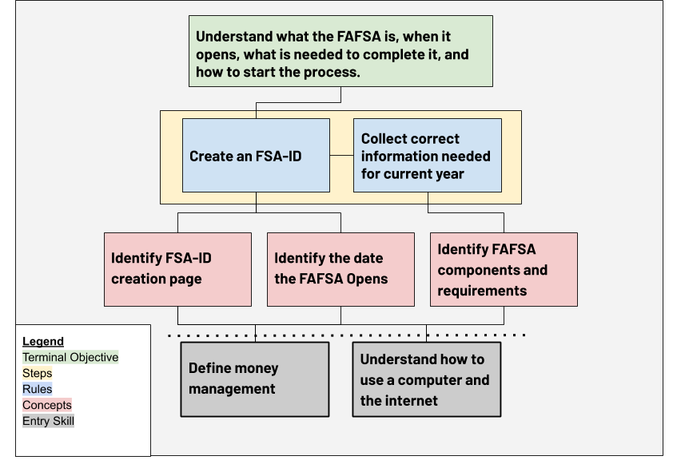
Figure A2.
ScholarshipWebpage
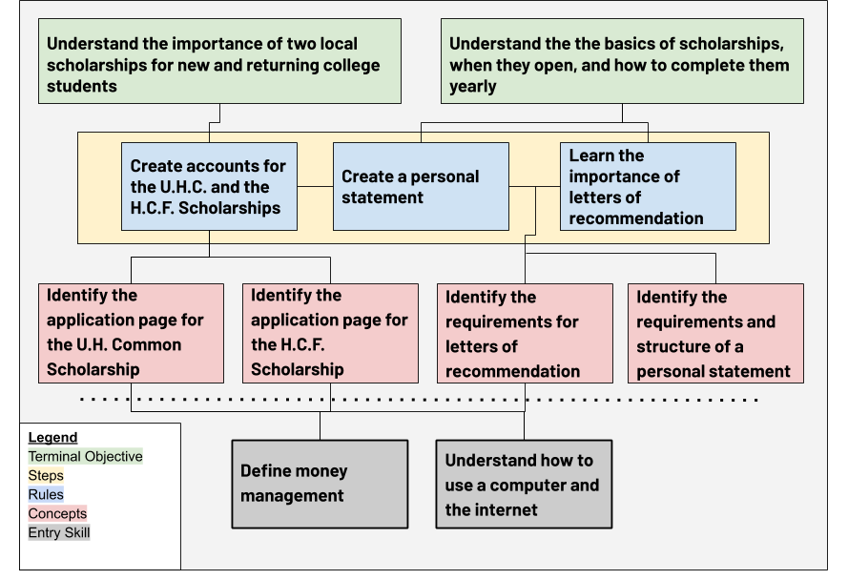
Figure A3.
Student Loans
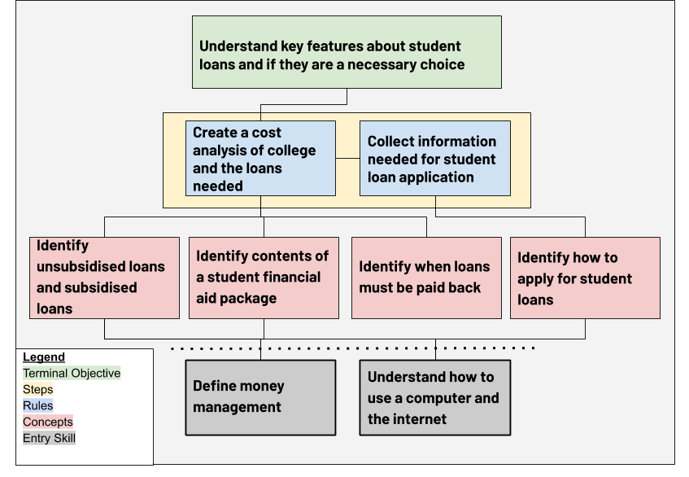

Appendix B: CITI Training
Figure B1
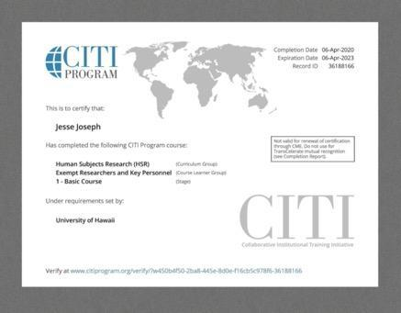
CITI Human Subjects Research Certificate

Figure C2
CITI Information Privacy Security Training Certificate

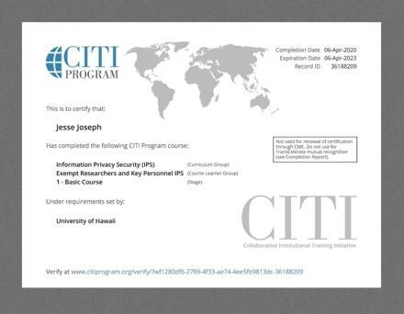

Appendix C: Usability Checklist

Figure C1
Modeled after checklists detailed in Rocket Surgery Made Easy: The Do-It-Yourself Guide to Finding and Fixing Usability Problems (Krug, 2010)
Before Completing Any Steps in this Checklist:
- Recruit participants via in person or over the phone communications.
- Set agreed upon date and time for the study to take place.
- Ensure participant is made aware of the study timeline

One Week Before Scheduled Session Dates
- Email participants a pre-written appointment reminder including instructions on how to download Zoom as well
  - Include flyer explaining the study in better detail

Two Days Before Scheduled Session Dates
- Email participants pre-written email reconfirming their scheduled appointment
  - Email to include Zoom invitation to the session
- Double-check that the necessary technology has been acquired and prepared for the test. (headphones, computer charging cables, microphones)
- Print this checklist to have a physical copy for the usability session
- Print data collection sheets for each participant

On Test Day

Before the Session Begins
- Prepare the materials required for the usability test
- Log into Zoom 20 minutes before the scheduled time to test all technology required for the session.
- Send participant pre-written email with consent waiver and questionnaire attached.
- Allow time for participants to check all technology required for the session.
- Allow time for participants to fill out the consent waiver and questionnaire.
- Begin recording the session.

During the Session
- Read allowed the usability testing script for the Financial Literacy Relay.
- Collect any information from any preliminary questions participants may have
- Guide the participant through the tasks located in the Financial Literacy Relay usability script.
- Keep a written record of observations and thoughts participants have while completing the tasks given

After the Session
- Read the conclusion of the script to close out the session
- Ask initial thought questions located in the Financial Literacy Relay usability script.
- Document responses.
- Stop recording the session.
- Sent participant the invitation to the post-survey.
- Conclude the meeting by ending the Zoom session
- Save Zoom recording securely on password locked harddrive

Appendix D: Questionnaire

Figure D1.

Participant Questionnaire – Demographics
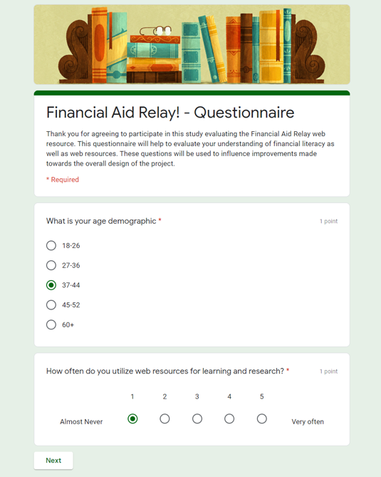

Figure D2.

Participant Questionnaire – Past Applications
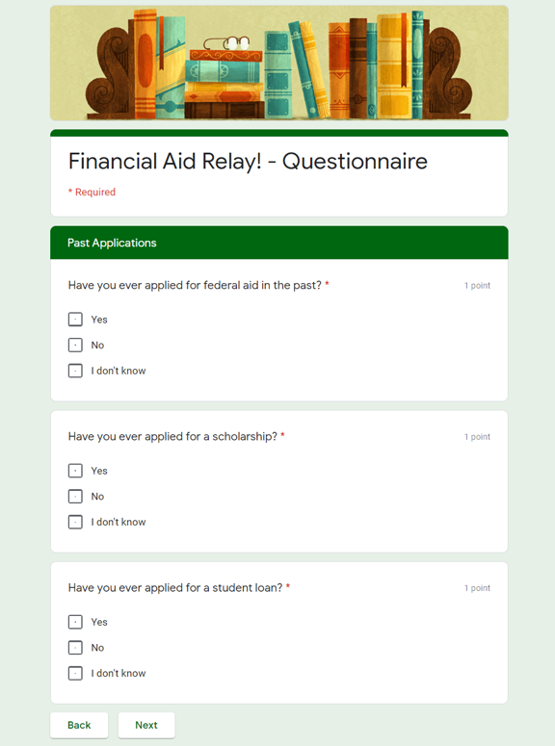
Figure D3.

Participant Questionnaire – Frequency and Definitions
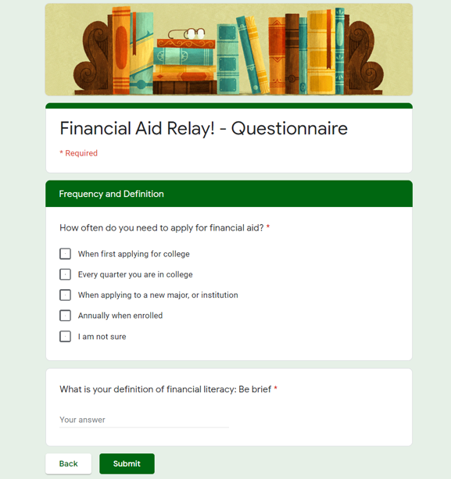

Appendix E: Usability Protocol
Figure E1
Usability Protocol - pg1
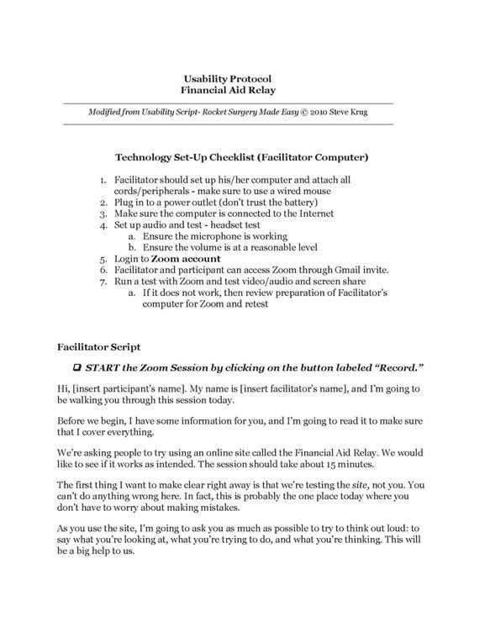

Figure E2
Usability Protocol - pg2
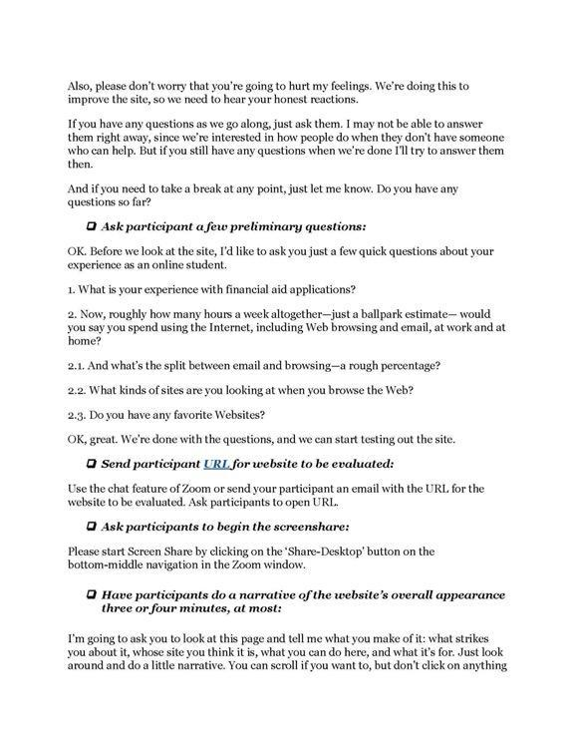

Figure E3
Usability Protocol - pg3
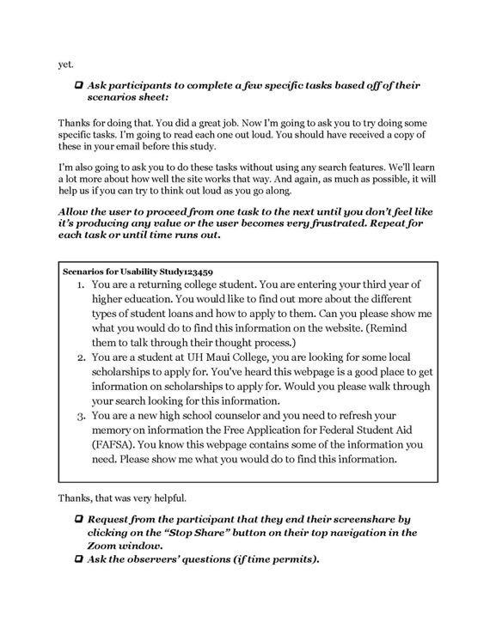

Figure E4
Usability Protocol - pg4
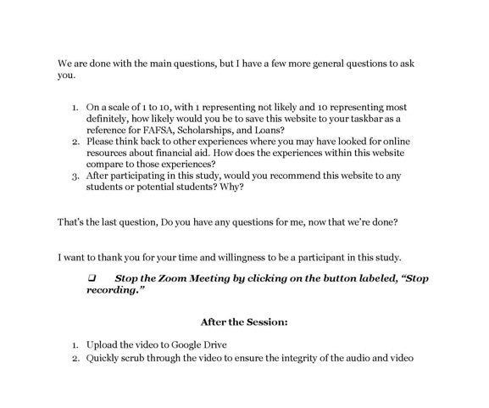

Appendix F: Post Survey
Figure F1
Post Survery
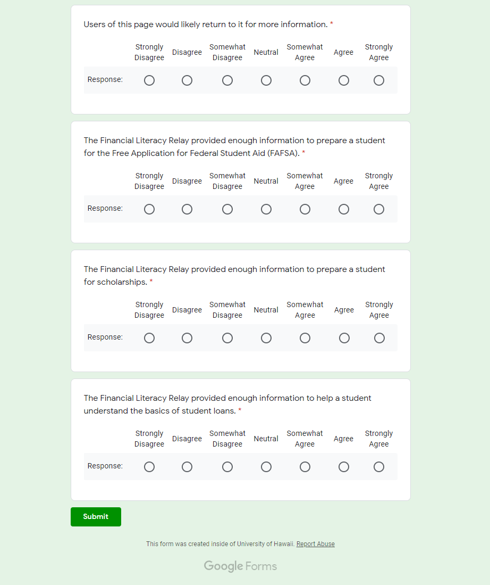

Figure F2

Appendix G: Promotional Flyer
Figure G1
Financial Literacy Relay Flyer
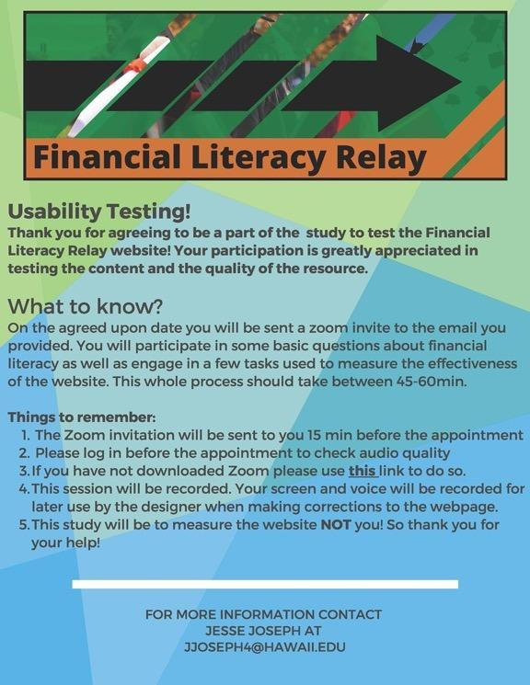

Appendix H: Email Communications
Figure H1

Confirmation, Reminder, and Consent Emails

Email: Appointment Confirmation and First instruction.

Aloha (Participant)

Thank you for agreeing to take part in a usability study of the Financial Literacy Relay website! This project will be a test of a new financial literacy resource, for more information please see the attached flyer for more information about the study. You will receive the invitation to the virtual meeting two days prior to your appointment.

Your scheduled appointment for the study will be at (Date)(Time)

Reminder:
You will need to download Zoom in order to participate in the study! You can find instructions on how to use Zoom here. You do NOT need to make a Zoom account but you will need to download the client if you have not done so already.

Please let me know if you have any questions before our scheduled meeting.

Thank you,
Jesse Joseph

Email: Appointment Reminder and Zoom invite

Aloha (Participant)

Your appointment for the Financial Literacy Relay webpage is fast approaching and I am looking forward to your participation! Below is the invite to our scheduled Zoom meeting as well as the link to download the Zoom client if you have not done so already.

Reminder:
- Your appointment is scheduled for (Date)(Time)
- You will need to download Zoom in order to participate in the study! You can find instructions on how to use Zoom here. You do NOT need to make a Zoom account but you will need to download the client if you have not done so already.

Zoom Invitation:
(Copy and paste Zoom invitation)

Thank you again and please let me know if you have any questions,

Regards,
Jesse Joseph

Email: Consent and Questionnaire

Aloha (Participant)

For our meeting today we will start with a consent form and questionnaire. This will be further explained during our session so please utilize this email as a reference for the attached consent form and linked Google Form. Remember that only after I receive a signed copy of your consent form will we begin the study.

Google Form Questionaire

(Attach Consent Form)

Thank you,
Jesse Joseph

Appendix I: Data Collection Worksheet:

Figure I1

Usability Study of Financial Literacy Relay

In-Session Data:
Participant Code:__________________ Date:__________________

Initial Questions Notes:
(Reminder: Following Usability Protocol and script, participants will be allowed to ask questions at the beginning of the study.)
-------------------------------------------------------------------------------------------------------------------
- -
- -
- -
- -
- -
- -
- -

Observations:
(Reminder: Notes on Participants actions and verbal process of the resource. Delayed response, confusion, and frustration need to be noted and described below to guide revision.)
Front Page:

- -
- -
- -
- -
- -
- -
- -

FAFSA Module:
- -
- -
- -
- -
- -
- -
- -

Scholarship Module:
- -
- -
- -
- -
- -
- -
- -

Student Loan Module:
- -
- -
- -
- -
- -
- -
- -

Post-Session Initial thoughts questions:
(These questions will be asked at the conclusion of the study and asked before participants are given the post-survey. Summarize responses.)

- On a scale of 1 to 10, with 1 representing not likely and 10 representing most definitely, how likely would you be to save this website to your taskbar as a reference for FAFSA, Scholarships, and Loans?

- Please think back to other experiences where you may have looked for online resources about financial aid. How does the experiences within this website compare to those experiences?

- After participating in this study, would you recommend this website to any students or potential students? Why?

Appendix J: Participant Code Log Example

Figure J1
Sample
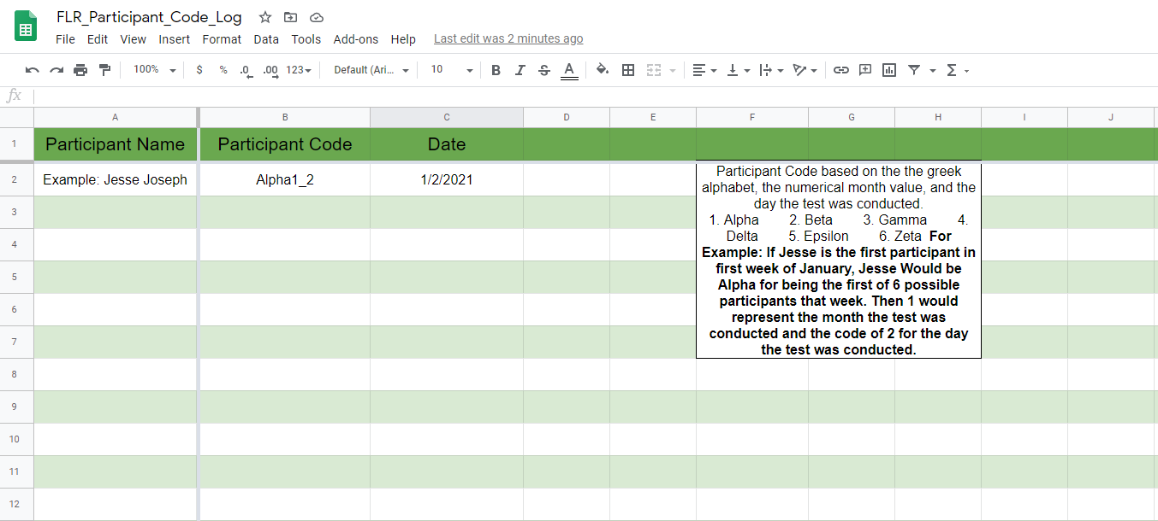

Note: Participant Code based on the greek alphabet, the numerical month value, and the day the test was conducted.
1. Alpha
2. Beta
3. Gamma
4. Delta
5. Epsilon
6. Zeta

For Example: If Jesse is the first participant in the first week of January, Jesse Would be Alpha for being the first of 6 possible participants that week. Then 1 would represent the month the test was conducted and the code of 2 for the day the test was conducted.

Appendix H: Consent Form

Figure H1

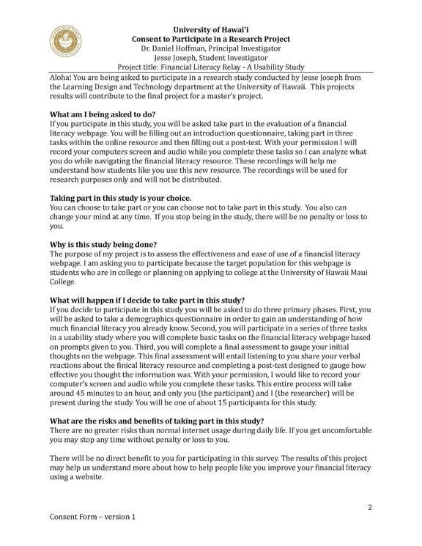
Figure H2
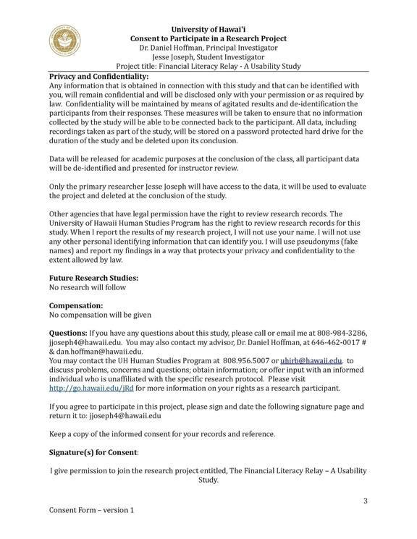

Figure H3

