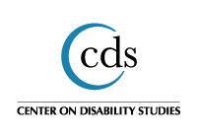
Center on Disability Studies, University of Hawai'i at Mānoa
Pacific Rim International Conference on Disability & Diversity

Opening Plenary: Dr. Patricia Morrissey and Tia Neils
Genesis Leong, Center on Disability Studies, University of Hawai'i at Mānoa, Hawai'i, United States, genesisl@hawaii.edu
Joshua Cruz, Center on Disability Studies, University of Hawai'i at Mānoa, Hawai'i, United States

Recommended Citation
Leong, G. (Ed.) & Cuz, J. (Trans.). (2020). Opening Plenary: Dr. Patricia Morrissey and Tia Neils. Pacific Rim International Conference on Disability and Diversity Conference Proceedings. Honolulu, Hawai'i: Center on Disability Studies, University of Hawai'i at Mānoa.
Licensed under CC BY 4.0. This article is brought to you for free and open access by the Center on Disability Studies, ISSN 2641-6115.

Opening Plenary: Dr. Patricia Morrissey and Tia Neils
Genesis Leong (Edited) and Joshua Cruz (Transcribed)
Center on Disability Studies, University of Hawai'i at Mānoa
Abstract: Discussion between Dr. Patricia Morrissey, Center on Disability Studies (CDS) director; and Tia Neils, The Association for Persons with Severe Handicaps (TASH) policy and advocacy director and Self-Advocates Becoming Empowered (SABE) founding member at the 35th Pacific Rim International Conference on Disability and Diversity on March 2, 2020, in Hawai'i. Included in this article are introductions to self-advocacy organizations (i.e., TASH, SABE, SARTAC⁠), employment and grant funding for leadership projects, and advice for self-advocates, parents, educators, other professionals and employers.
Keywords: Disability; Self Advocates; PacRim2020
Knowledge Focus: Advocacy/Activism Focus; Best Practices
Topic Area: Inclusion

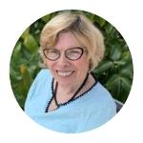
Introduction: Tia Nelis
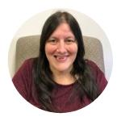
Pat Morrissey: Tia Nelis is the in-house advocate for TASH¹. She goes around sharing with people with disabilities (PWD) and without disabilities how important it is to work together to bring about a more inclusive society. Tia has traveled, almost, all of the world. She's one of the wisest people I know, and is also very honest and very diplomatic. Tia, I'm gonna start by asking you to tell us a little bit about your job at TASH to the kinds of things you do.
Tia Neils: Good morning everybody, my name is Tia Nelis. I work at TASH as the policy and advocacy director, working on policies for people with disabilities. We look at anything that relates to those policies and committees, or any kind of piece of legislation that's involved in helping support PWD get their rights and their services. And to make sure that things that are important to us don't get cut. I'm involved in the youth employment grant. Right now, I am doing a career developing committee that helps people think about careers and access jobs. It is important to have people explore more and talk about why their careers are so important to them. People with disabilities can have careers with the right support and they have a need right now.
And we are having careers and more and more of our friends want those things too. They want to have jobs that pay well, and have benefits like vacation and sick time just like everyone else. So we're putting together a manual that will turn into an app for people's smartphones and iPads, which I'm very excited about because a lot of the young people love to be on the computer, apps, and with everything fit for the internet. So that's part of my job, also I network and go to meetings that help support PWD speak up and make their dreams happen.

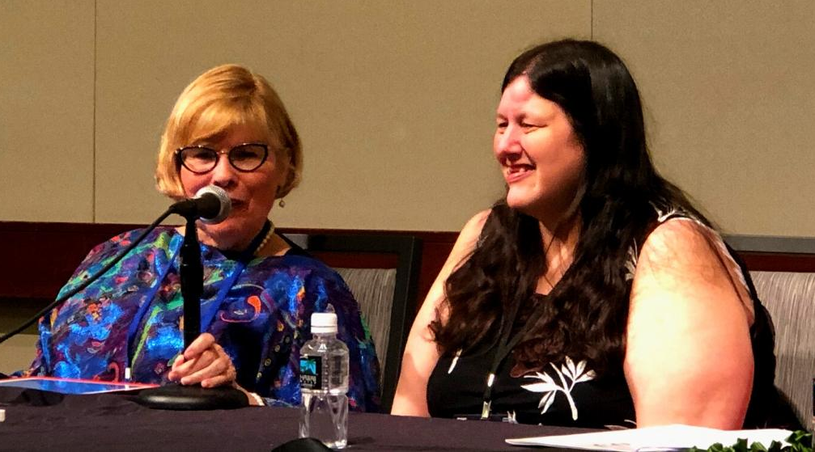
SABE: Priorities for the Immediate Future
Pat: She has a big job! Second question: Tia is a founding member of Self-Advocates Becoming Empowered (SABE)², it would be helpful to know more about SABE and what priorities it has for the immediate future.
Tia: So SABE is now going to be 30 years old and we are very excited about that. SABE divides the United States into nine regions with two representatives for each region. We work on things that are about building our self-advocacy stronger. One of the greatest things that we're really proud of right now is the start of the Self Advocacy Resource and Technical Assistance Center (SARTAC) with funding from the Administration Community Living (ACL). We are able to provide technical assistance for people with disabilities that help self-advocacy groups to grow stronger and become stronger leaders. Not only that, the really great thing is that we are providing an employment opportunity.
We have SARTAC bubbles that are going to different places like working for the art for a leadership project. And so these leadership projects are funded by SARTAC, in which people apply for funding to do a leadership project. And there's been quite a bit of follows now.
So we've had the grant, it's in the fourth year now. We had five years with this grant. We've been doing some pretty amazing things. People have been doing some pretty amazing leadership projects, and had an opportunity for employment after they’ve finished their leadership project. So that's really been pretty awesome. There's been a lot of great projects that came out of that, and people have actually gotten jobs on that after their leadership project is done. And it's not like:
‘Oh, we're going to help them learn how to take out the garbage, fax, or do those really things that are meant to help them and improve their skills and put that on their resumes. No, it's an actual leadership project that the organization and the person with the disability has to work together, to come up with a project that they are going to be doing.’

Advice for Self-Advocates, Parents, Professionals & Employers, and International
Pat: Nice, that's very exciting! Now I'm going to challenge her. I'm going to ask a question and Tia will answer from five different perspectives. Our audience includes self-advocates, parents, educators, other professionals and employers, as well as participants from all over the world. If you could get one piece of advice, each, what would it be? So let's start with self-advocates.
Tia: One piece of advice for self-advocates, speak up for what you want.
Pat: Okay. How about parents?
Tia: Parents teach your kids early about self-advocacy.
Pat: Professionals like educators, professors, and all those guys that think they know it all.
Tia: Listen, listen, listen to people with disabilities and include as early on your projects not in the middle or when you need a token.
Pat: Employers?
Tia: Hire people with disabilities. We make good employees.
Pat: Okay. And how about foreign visitors?
Tia: If your country is not signed to the CRPD³, please do so immediately.
Pat: Amen. That includes the U.S.! Okay, in a few minutes. I'm going to ask one more question. I'd like you to give a little bit of a heads up on your two-hour workshop and give some people a preview on what you are going to talk about.
Tia: I'm really excited we're going to do a two-hour workshop about person centered planning, real person centered planning, where the person is in charge. And we're going to talk about different tools that people can use around person centered planning, around employment and also around people with disabilities speaking up for what they want.
Pat: Thank you very much. She is really amazing. I hope you have a chance to talk to her over the next two days. Like I said, she's the smartest person I know.

Presenters
Patricia Morrissey, PhD, is president of the U.S. International Council on Disabilities and was a member of the U.S. delegation when the U.N. CRPD was being drafted. Dr. Morrissey directs the Center on Disability Studies, which conducts research, training, demonstration, evaluation, and dissemination activities to build capacity and systems change in Hawai'i and Pacific Island Nations, so individuals with disabilities participate fully in community life—in education and through access to employment, housing, transportation, health care, and leisure-activities. She believes everyone is entitled to a full, satisfying life. She is committed to making it happen for the full range of individuals with disabilities.
Tia Nelis is the policy and advocacy director for TASH. Her proudest achievement as a self-advocate is when she found her voice by learning about self-advocacy with her friends. All of them coming together as a group with support, learned about self-advocacy and other leadership skills. That taught them how to speak-up and use their voice. Today, she gets to share her advocacy skills and leadership skills with others as a part of her job. She gets excited when she supports other people to find their voice and see them speak-up for what they want for the first time and to know that she had something to do with it. Tia is the past president of Self-Advocates Becoming Empowered and a trained facilitator of person centered planning using PATH (Planning Alternatives Together with Hope).

Authors
Genesis Leong (Ed.) is a public information specialist at the Center on Disability Studies, University of Hawai'i at Mānoa (UHM), and was recently the assistant editor/Journal manager of the Review of Disability Studies Journal: An International Journal. She is the program & call for proposals coordinator for #PacRim2020, a position that proceeds her 15-years of experience in organizing projects & events throughout the University of Hawai'i System. Her studies are focused on the interdisciplinary approach to Disability Studies & Disaster Planning Studies, and she is currently enrolled in the Disaster Management & Humanitarian Assistance program at the UHM, Department of Urban & Regional Planning.
Joshua Cruz (Trans.) recently graduated from the University of Hawai'i at Mānoa in Computer Engineering. He was the computer support assistant at the Center on Disability Studies. Joshua enjoys spending my time on the computer, working efficiently, and learning about the tech world.

References
SABE. (2020). About SABE. Retrieved on June 1, 2020, from https://www.sabeusa.org/meet-sabe.
TASH. (2020). About TASH. Retrieved on June 1, 2020, from https://tash.org/about.
United Nations Convention on the Rights of Persons with Disabilities (CRPD). Convention on the rights of persons with disabilities and optional protocol. Retrieved on June 1, 2020, from https://www.un.org/disabilities/documents/convention/convoptprot-e.pdf.

Endnotes
1. The Association for the Severely Handicapped (TASH) is an international organization in disability advocacy, “the mission of TASH is to promote the full inclusion and participation of children and adults with significant disabilities in eerie aspect of their community, and to eliminate the social injustices that diminish human rights” (TASH, 2020, para. 4).
2. The Self Advocates Becoming Empowered (SABE) is a United States disability advocacy organization. The mission is “To ensure that people with disabilities are treated as equals and that they are given the same decisions, choices, rights, responsibilities, and chances to speak up to empower themselves; opportunities to make new friends, and to learn from their mistakes” (SABE, 2020, para. 2).
3. The Convention on the Rights of Persons with Disabilities (CRPD) is a United Nations international treaty recognizes “mainstreaming disability issues” (p. 2) and “the need to promote and protect the human rights of all persons with disabilities” (p. 3).

